**Party Vote Change of Presidential Elections between 2000 and 2016**

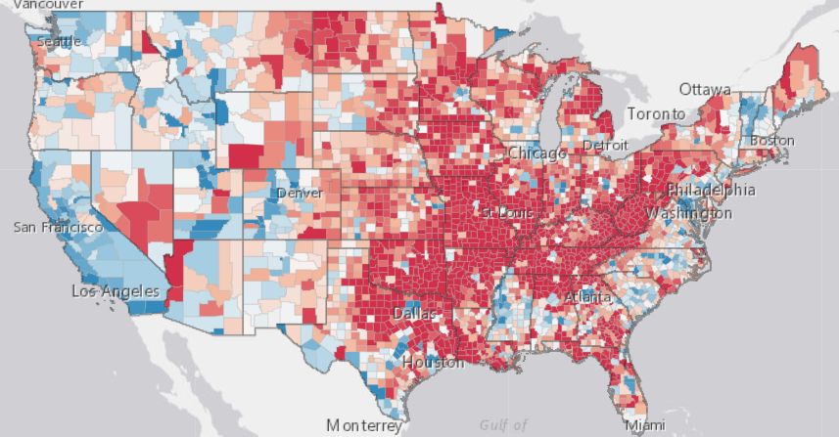

Figure : Macro Level of 2000 to 2016 comparison

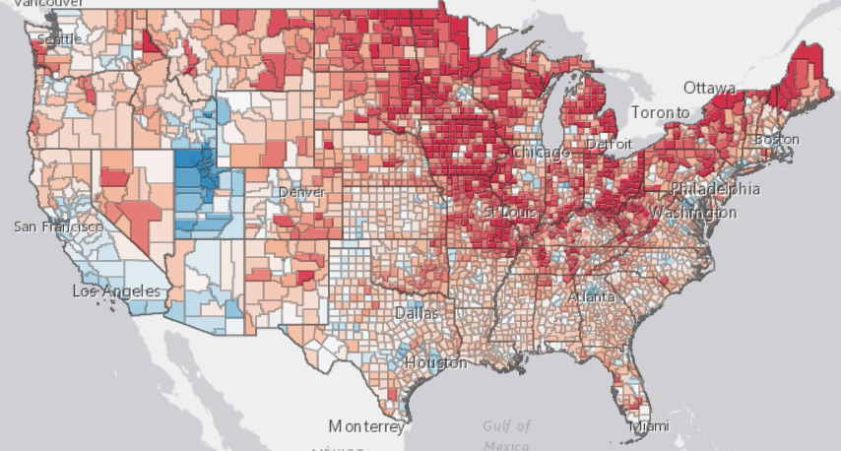

Figure : 2012 vs 2016. aka Obama Trump voter map

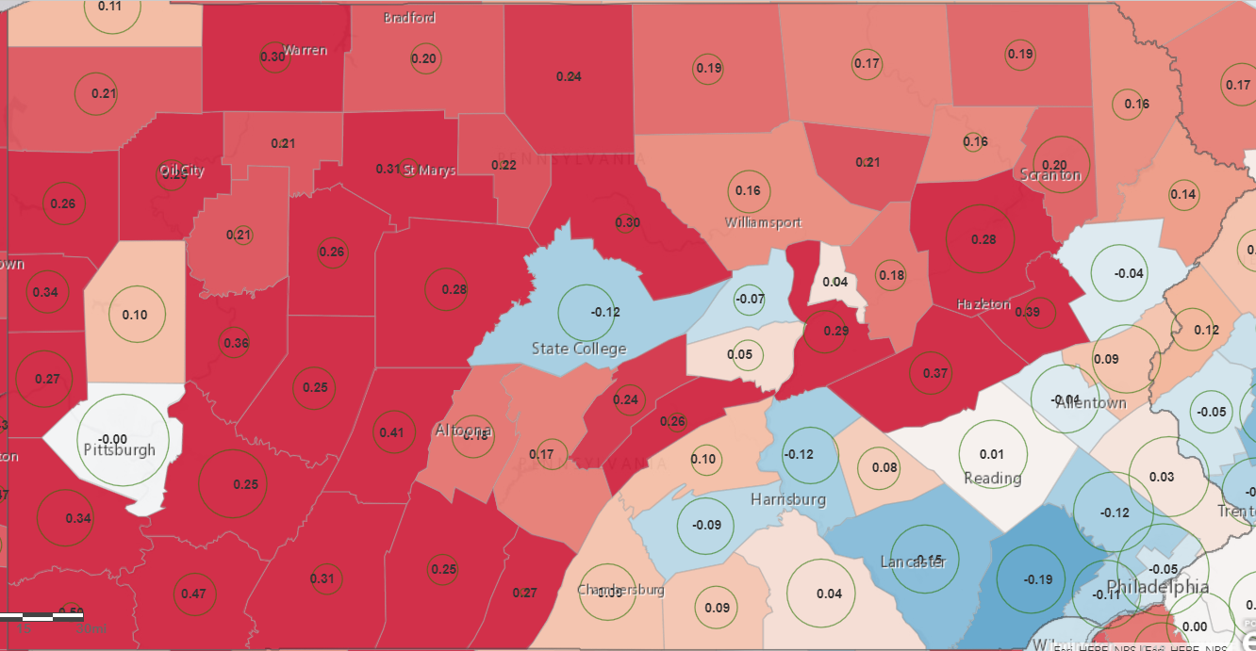

Figure : Detail Level 2000 vs 2016 Pennsylvania

**Introduction**

My map shows the shift in American politics between any two chosen presidential elections between 2000 and 2016. Therefore, I made 10 layers of percent change for each election comparison, then I have a layer of county border & population, and state border. Users can identify on the national and regional level the locations that are shifting towards the democrats (blue) and the republicans (red). I made it for anyone interested in politics and elections, and it could even be used by those who are trying to figure out where to focus campaigning and get out the vote efforts.

**Data Cleaning**

Fortunately, the data that I found from

<https://dataverse.harvard.edu/dataset.xhtml?persistentId=doi:10.7910/DVN/VOQCHQ>

worked but only served as the foundation for my analysis. Originally, I wrote a long explanation for the extensive cleaning, but I instead now have images showing large steps of progress.

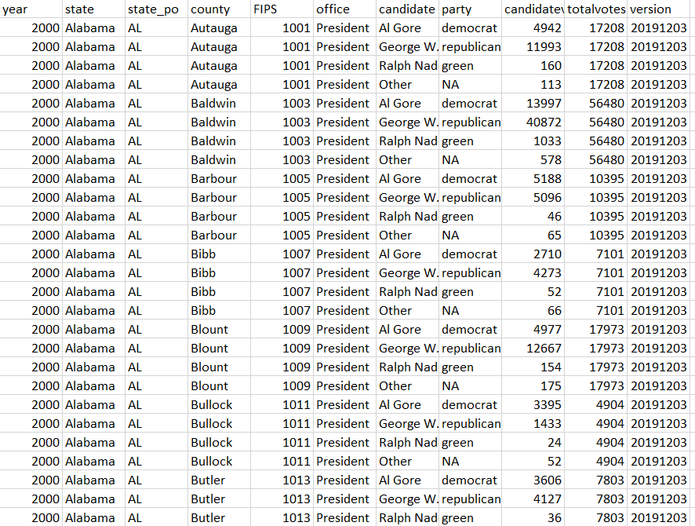

Figure : Sample of the 50525 rows I started with

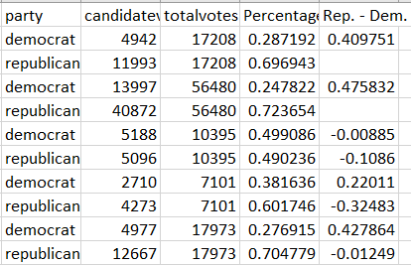

Figure : First Calculations after cleaning

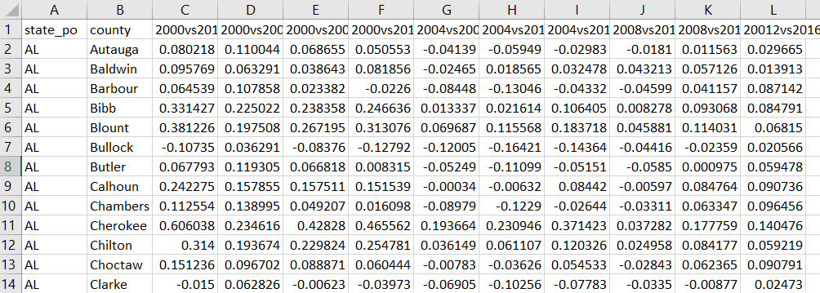

Figure : Final Form of the Data

I ended with this with only 3155 rows identified by a combination primary key of state_po and county, because neither one is unique individually, but combined they are.

**Creation of the map and design choices**

For map projection and reference map I kept things simple with web Web Mercator on top of the light gray canvas. I decided on Web Mercator because of its common use, anything outside of that would be more likely to distract the user than help. Plus, its only for the United States so enlargement near the poles isn’t major. I used light gray because it had the least in the background. A more significant background for my project was the county data that I found and that was used as the base from which the data was enhanced or joined. I gave them a lighter background than I used in the beginning based off advice that I saw in the slides. I gave a heavier background to the states to help orient viewers quickly.

I decided to add the zoom in values of population, from simple data enrichment, and exact percent change, with labels, after finding that though the map was useful on a macrolevel if you wanted any detail it was near useless. You could click the townships for info, but it’s filled with junk and slow. Therefore, I created the label to show exactly how much change occurred. But with this solved I found the problem that the radical changes were always going to be shown in small townships. It’s more significant for a township of 1,000,000 to change 5% than one of 1,000 to change 40% for example. I drew attention to the more populated townships through circles centered on each township of size reflecting the population.

Choosing the two main colors themselves was simple with blue and red and their shading imbedded into the American political psyche. I did run into a problem though that when you choose diverging color schemes the option to manually choose the color intervals goes away. You can choose center and change rate so it’s still consistent, but I can’t make an easy to read key. This served to only make the zoom in text label of exact change to be more important. It being text, black just looked best. However, choosing the circle for population was difficult since there really wasn’t a perfect color for the outline. I tried ColorBrewer and asked advice from more artistic family members, but after sampling several colors decided finally on a medium green as I felt I worked best against the blue and green

**Things that could be added or improved**

One idea was to program a timeline like tool to change the layers with its two sliders going to certain election years instead of clicking layers on and off. However, I decided it was not worth the trouble after trying to figure it out. Also, I wish I had a better way to represent population. I have seen maps changing sizes of counties based on population which would be ideal but difficult. In terms of trial and error on the map trying to choose max, min, and cutoffs for circle size was very time consuming but I got it to the best balance of seeing it in the rural areas and not complete overwhelming things on the coasts I could get, but it is still the most frustrating thing for me.

**My link**: https://arcg.is/0uCPuq